**GUNS –AMMUNITION & ACCESSORIES “ABSOLUTE AUCTION”**

***100+ GUNS!!***

**17717 Newcomb Road Middlefield, Ohio 44062**

**WEDNESDAY, December 18th, 2024 at 5:30 P.M.**

**GUN COLLECTION-AMMUNITION & ACCESSORIES**

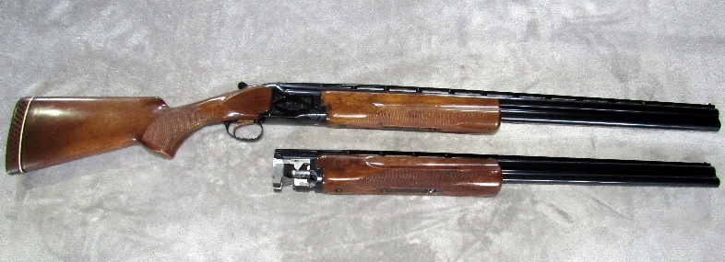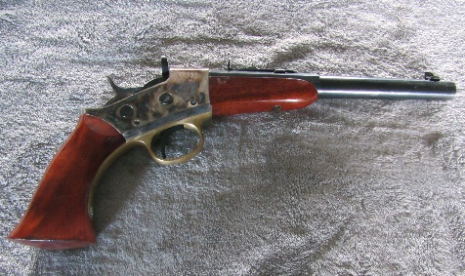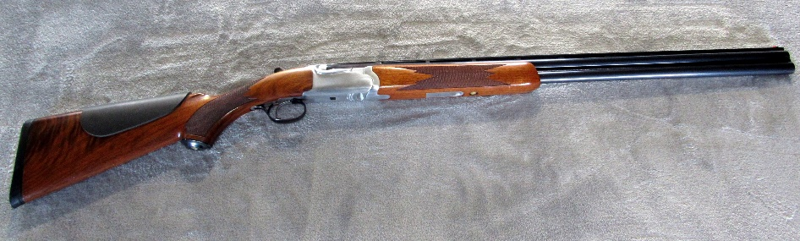

***GUNS****:* Browning Citori 12 or 20 ga. BBL original hard case, Browning Superposed 12 ga. original hard case, Browning A-5 Sweet 16 16 ga., Remington 1100 28 Sporting 28 ga. NIB, Remington 1100 410 ga., Remington 1100 16 ga., Remington 1100 12 ga., Remington 1100 20 ga., Remington 780 .308 Win. Redfield 2x7 scope, Winchester 94AE .444 Marlin, Marlin JM stamp 444 SS .444 Marlin, Winchester 1400MK11 12 ga. Vision Plus scope, Rock-Ola US Carbine .30mm 5 magazines, Remington 870 Wingmaster 12 ga., Remington 870 Wingmaster 16 ga., Ruger American 450 Bushmaster Nikon 3x9 scope, Remington 700 22-250, Remington 700 22-250 Simmons 3.5x9 scope, Winchester 101 12 ga., Mauser 98 7mm-06 Bushnell 3.5x10 scope, Savage Axis .223 Rem. Bushnell 4x12 scope, Ruger American .350 Legend Leupold 4.5x12 scope, Sturm Ruger & Co. Red Label 20 ga. 3” chamber, Aselkon Red Stone 12 ga. NIB, Remington 1187 12 ga., Savage 30 Series C 410 ga., Ruger 7mm Rem. Mag., Ruger 1 30-06, Winchester 70 .243 Win., Browning 1885 45-70 Gov. octagon barrel, Henry H006M Big Boy Brass .357 Mag. .38 Special, Winchester 70 Pre 64 .257 Roberts Balvar 2.5x8 scope, Winchester 70 .270 Win. Weaver 2.5x7 scope, Winchester Ranger 30-30, Remington 541-S Custom Sporter .22 S, L, LR Nikon scope, Winchester 42 410 ga., Remington 3200 Special Trap 12 ga. OU, Savage 10 22-250 Simmons scope & bipod, Browning SA-22 .22 LR Leupold 2x7 scope, Savage Axis .308 Weaver 3x10 scope, Savage Axis .270 Win. Bushnell 3x9 scope, Remington 541S Custom Sporter .22 S, L, LR, Browning Medallion A-Bolt 30-06, Thompson Center Compass .204 Ruger Burris 3x9 scope, Ruger 10-22 .22 LR NcStar 3x9 scope, Mosin Nagant 7.62x54R bayonet, CZ 628 28 ga., Mossberg 500 410 ga., Remington 1100 12 ga. rifled barrel, Browning 12 20 ga. NIB, Marlin 1894 .45 Colt, Savage Edge 22-250 NIB, Mossberg NWTF 4x4 30-06 Springfield Mossberg 3x9 scope NIB, Springfield Armory MIA 7.62x51 2 magazines Meyopta 4-20x50 scope, Marlin 410 410 ga. NIB, Savage 555 28 ga. NIB, Winchester XPR .350 Legend Vortex 3x9 scope, Savage 555 410 ga. NIB, Browning BPS Special 20 ga. NIB, Browning Cynergy Wicked Wing 12 ga. OU, Remington Peerless Field 12 ga. OU, Browning Elite 28 ga. OU NIB, Mossberg 500 410 ga., Marlin JM Stamp 894 .44 Rem., Dickinson Arms 28 ga. SxS, Ruger 77 Hawkeye 7mm Rem. Mag. NIB, Spartan SPR310 12 ga., Savage 93 .22 Mag. Bushnell scope, Marlin 1894 Carbine .357 Mag. Tasco 3x9x40 scope, Winchester 94 30-30 Tasco 3x9 scope, Browning BPS 12 ga., Marlin 336C .35 Rem., Ruger 77 Mark II .270 Win. Tasco 4x16 scope, G Force Arms GF2P-Pax 3” chamber 12 ga., AKSA Arms S4 12 ga., Meffert Drilling Double 16 8mmx.57, Ruger Super Red Hawk .44 Mag. Hammer 2x20 scope, Bond Arms Ruffneck 9mm, Springfield 1911 .45 auto, Colt DA38 Revolver Officer .38, Walther PPK .380 ACP, Smith & Wesson M629-2 .44 Mag. SS, Springfield XPS .45 ACP 3 magazines, Ruger Single 6 .22 Revolver, Ruger Bisley Black Hawk New Model .45, Ruger Black Hawk New Model .30 Carbine Revolver, Colt King Cobra 2” barrel .357 Mag. SS NIB, Springfield XDM-10 10mm auto with light, Colt Gov. Model Rail Gun .22 LR NIB, Smith & Wesson 500 .500 S&W SS, Smith & Wesson 67-1 .38 S&W SS Revolver, Glock 21 .45 auto, Bergara B14 .300 W.M. with muzzle brake, Ruger Black Hawk .45 SS, Taurus G2C PT 111G2A 9mm, Uberti CAT1550 .357 Mag., Smith & Wesson M&PT Shield 9mm Crimson Trace Red Dot scope, Rossi Brawler 410-.45 Colt NIB, Glock 19 Trump 45th 9mm NIB, Remington XP101 .223 Rem. Leupold scope, Byrna HD self-defense pepper gun.

**AMMUNITION ETC.:Federal .38 Special 150 grain, Igman 6.5 & 55mm 139 grain, CCI .22 Varmint 30 grain, Winchester .45 Colt, Federal .270 Win. 140 grain, Federal Premium 30-06 Springfield 150 grain, Federal .300 Win. Mag. 180 grain, Remington .45 Colt 250 grain, PMC Bronze .45 auto FMJ 230 grain, PMC 22-250B, Federal .270 Win. 140 grain, .223 Rem. 1000 rounds, Winchester 7.62x51mm 135 grain, Federal .308 Win. 110 grain, Wolf .223 Rem. 55 grain, Lellier & Bellot .30 Carbine FMJ 110 grain, Lellier & Bellot .45 auto 230 grain FMJ, Federal .45 auto 230 grain Hydro Shock JHP, Fiocchi .380 auto 95 grain, Winchester .45 auto 230 grain FMJ, Hornady Critical Defense .45 auto 185 grain FTX, PMC .223 Rem. 55 grain , Winchester .380 auto 95 grain FMJ , Federal 5.56x45mm 62 grain FMJ , PMC .45 auto JHP 185 grain , American Eagle .45 auto 230 grain FMJ, PPU 7.62x54R 182 grain FMJ BT, Federal .45 auto Plus P 230 grain HST, Winchester 7.62x51mm 147 grain FMJ, Hornady .223 Rem. 55 grain, Federal .223 Rem. 55 grain FMJ, PPU 7.62X54R 182 grain, Aguila .30 Carbine 110 grain, Baraul 5.56x45 55 grain, Blazer .380 auto 95 grain, Remington 12 gauge barrel, Mossberg 12 gauge Slugster barrel, Remington LT 20 20 gauge barrel, Remington 12 gauge barrel, Rage Yrypan NC 2 blade 100 grain broadheads, 3 Realtree 3XL Longsleeve Performance Tee, CCI .22 Varmint 30 grain, AIRSTRIKE 15 foot ladder stand, Buckmaster Sig Sauer 3-9x40MM BDC Rifle Scope, gun cleaning kit, gun sling, leather shoulder holster with magazine pouch, holsters.**

***View listing and photos on auctionzip.com ID# 13983***

**TERMS: We will accept Cash, Check, Debit card, Visa-Mastercard-Disc with proper ID.** There is a 5% Buyer’s Premium on all sales. 5% will be waived if paid with cash or good check. You must be 18 or older to purchase long guns, be 21 or older to purchase hand guns, be an Ohio resident to purchase firearms at this auction.

***Auctioneer: Crist F. Miller Assisting Auctioneer: Urie Byler***

**Owner & Miller not responsible should any accidents occur.**

***Auctioneer’s Note:* “GREAT QUALITY AUCTION” GOOD CLEAN GUN COLLECTION**

**This is an auction that you don’t want to miss!!**

**Lots of GOOD QUALITY ITEMS! Food Available Bring your family for an exciting evening at this Auction!!**

**TERMS: We will accept Cash, Check, Debit card, Visa-Mastercard-Discover with proper ID.**

**There is a 5%**

**FREE DRAWINGS: One gun drawing!!**

**YOU WILL BE ENTERED EACH TIME YOU PURCHASE A GUN! NEED TO BE PRESENT TO WIN.**

**2025 Calendar Drawing with 62 chances to win a gun.**

**The Calendar Winner will be the Buyer of the Highest Selling Gun at This Auction.**



**GUNS –AMMUNITION & ACCESSORIES “ABSOLUTE AUCTION”**

***100+ GUNS!!***

**17717 Newcomb Road Middlefield, Ohio 44062**

**WEDNESDAY, December 18th, 2024 at 5:30 P.M.**

**GUN COLLECTION-AMMUNITION & ACCESSORIES**

**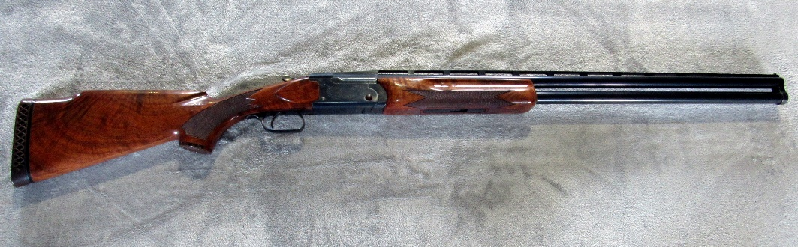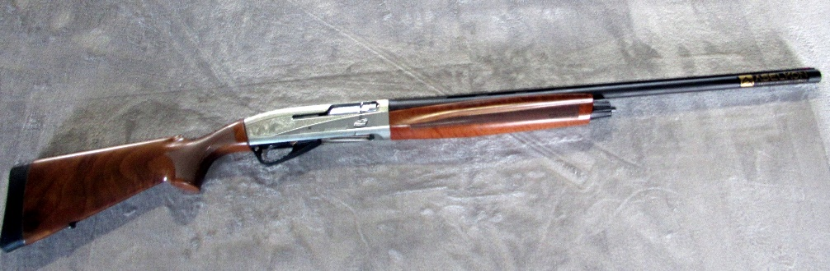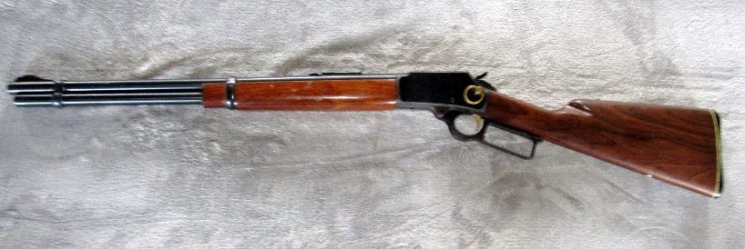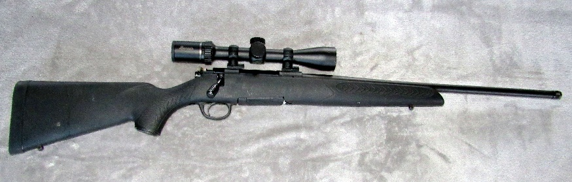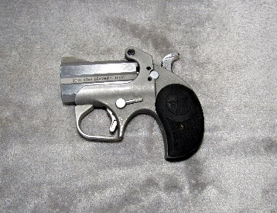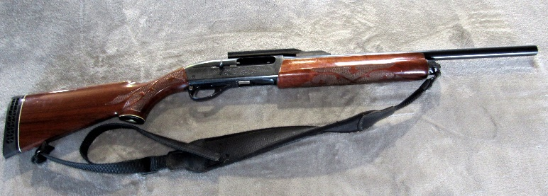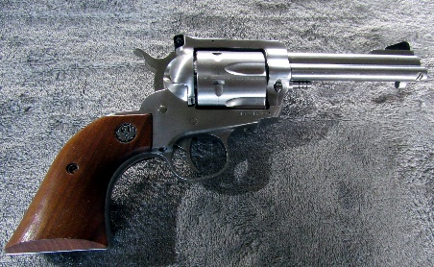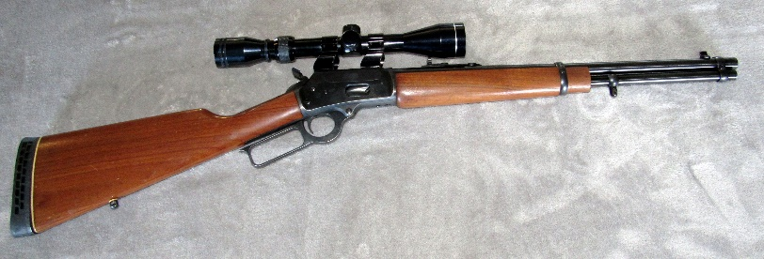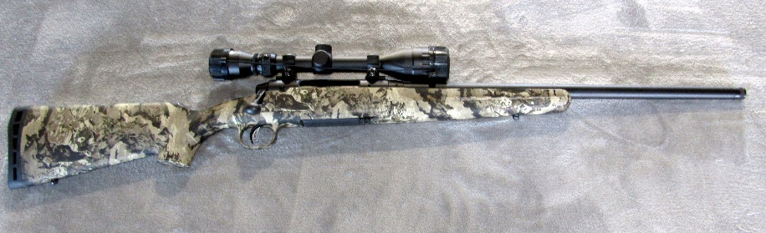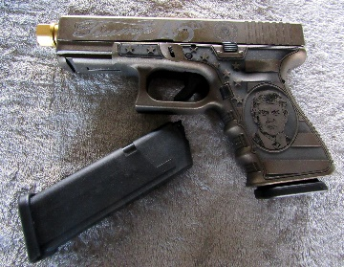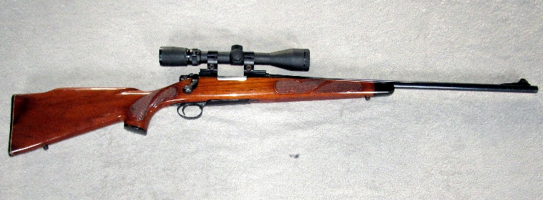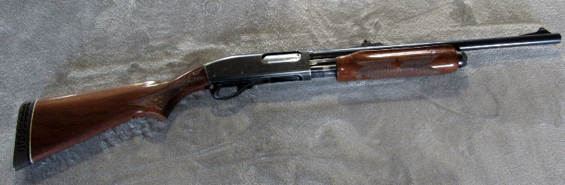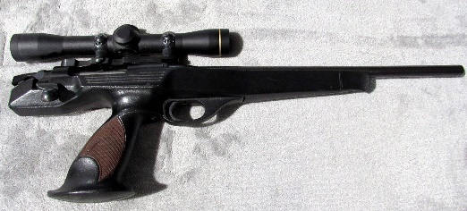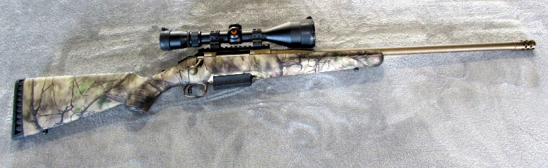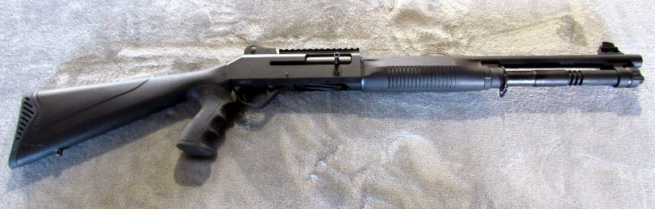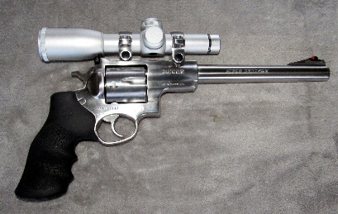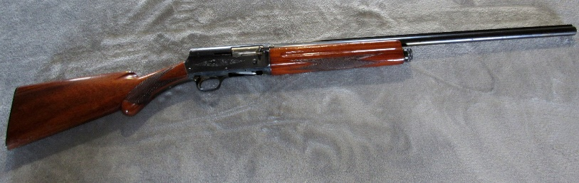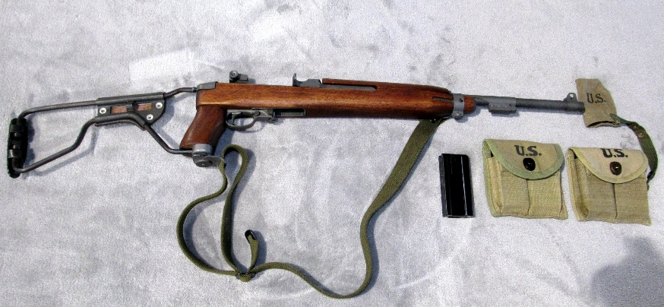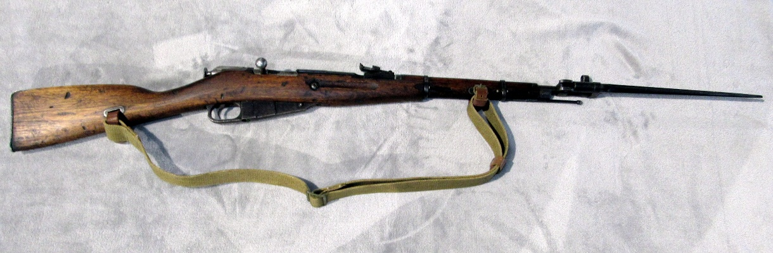****

**FREE DRAWINGS: One gun drawing!!**

**YOU WILL BE ENTERED EACH TIME YOU PURCHASE A GUN! NEED TO BE PRESENT TO WIN.**

**2025 Calendar Drawing with 62 chances to win a gun.**

**The Calendar Winner will be the Buyer of the Highest Selling Gun at This Auction.**